UNITED STATES

SECURITIES AND EXCHANGE COMMISSION
Washington, D.C. 20549

FORM 8-K

CURRENT REPORT
Pursuant to Section 13 or 15(d) of
The Securities Exchange Act of 1934

Date of Report (Date of earliest event reported): October 23, 2019

Consolidated-Tomoka Land Co.

(Exact name of registrant as specified in its charter)

Florida | 001‑11350 | 59‑0483700
(State or other jurisdiction of | (Commission File Number) | (IRS Employer Identification No.)
incorporation) | 1140 N. Williamson Blvd., | 32114
 | Suite 140 | (Zip Code)
 | Daytona Beach, Florida
 | (Address of principal executive offices)
Registrant’s telephone number, including area code: (386) 274‑2202
Not Applicable

(Former name or former address, if changed since last report.)

Check the appropriate box below if the Form 8‑K filing is intended to simultaneously satisfy the filing obligation of the registrant under any of the following provisions:
- ] Written communications pursuant to Rule 425 under the Securities Act (17 CFR 230.425)
- ] Soliciting material pursuant to Rule 14a‑12 under the Exchange Act (17 CFR 240.14a‑12)
- ] Pre-commencement communications pursuant to Rule 14d‑2(b) under the Exchange Act (17 CFR 240.14d‑2(b))
- ] Pre-commencement communications pursuant to Rule 13e‑4(c) under the Exchange Act (17 CFR 240.13e‑4(c))

Securities registered pursuant to Section 12(b) of the Act:
 | Title of each class: |  |  | Trading Symbol |  | Name of each exchange on which registered:
 | COMMON STOCK, $1.00 PAR VALUE PER |  |  | CTO |  | NYSE American
 | SHARE

Indicate by check mark whether the registrant is an emerging growth company as defined in Rule 405 of the Securities Act of 1933 (§230.405 of this chapter) or Rule 12b‑2 of the Securities Exchange Act of 1934 (§240.12b‑2 of this chapter).

Emerging growth company ☐

If an emerging growth company, indicate by check mark if the registrant has elected not to use the extended transition period for complying with any new or revised financial accounting standards provided pursuant to Section 13(a) of the Exchange Act. ☐

Item 7.01. Regulation FD Disclosure.

On October 23, 2019 Consolidated-Tomoka Land Co. (the “Company”) issued a press release announcing the creation and planned initial public offering of Alpine Income Property Trust, Inc. (“Alpine”), and CTO’s intention to sell or contribute to Alpine a portfolio of 20 of the Company’s single-tenant net lease income properties. The Company also announced that its investment strategy will focus on higher return real estate assets, and that the Company will rebrand itself as CTO Realty Growth, Inc. The press release is attached hereto as Exhibit 99.1.

A copy of materials that will be used in investor presentations delivered by representatives of the Company from time to time is attached to this Current Report on Form 8‑K as Exhibit 99.2. These materials are dated October 23, 2019 and the Company disclaims any obligation to correct or update these materials in the future.

The information contained in this Current Report Form 8‑K is being furnished pursuant to Item 7.01 of Form 8‑K and shall not be deemed to be “filed” for purposes of Section 18 of the Securities Exchange Act of 1934, as amended.

Item 9.01. Financial Statements and Exhibits.

(d) Exhibits

99.1 Investor Presentation – October 23, 2019

99.2 Press Release – October 23, 2019

SIGNATURES

Pursuant to the requirements of the Securities Exchange Act of 1934, the registrant has duly caused this report to be signed on its behalf by the undersigned hereunto duly authorized.

Date: October 23, 2019

By:/s/Mark E. Patten

Mark E. Patten
Senior Vice President and Chief Financial Officer
Consolidated-Tomoka Land Co.

Exhibit 99.1
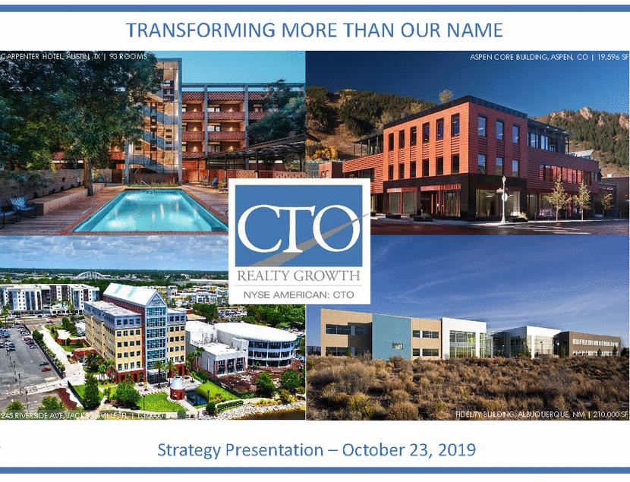

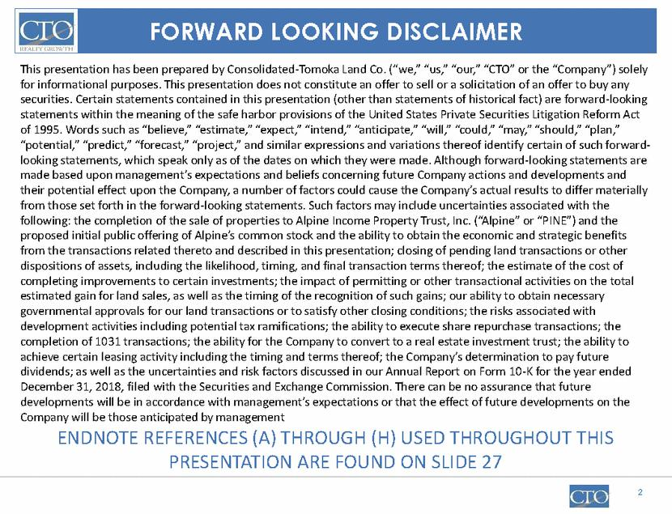

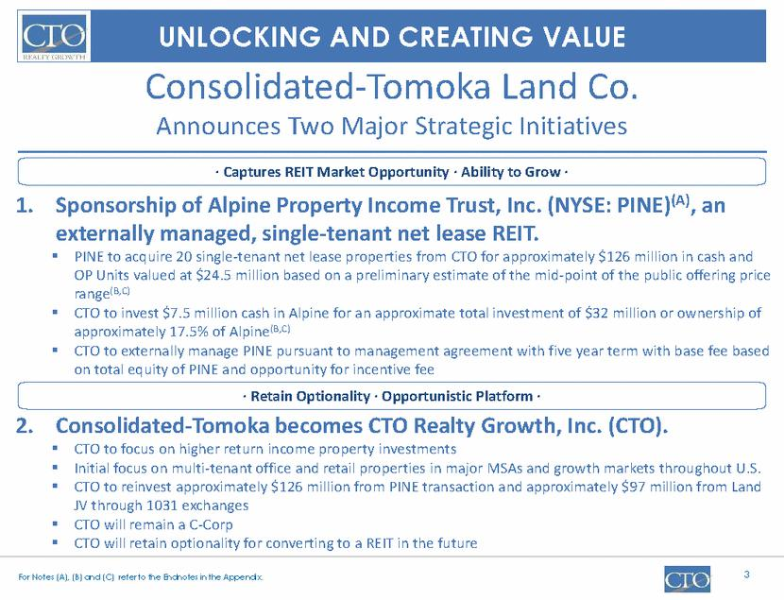

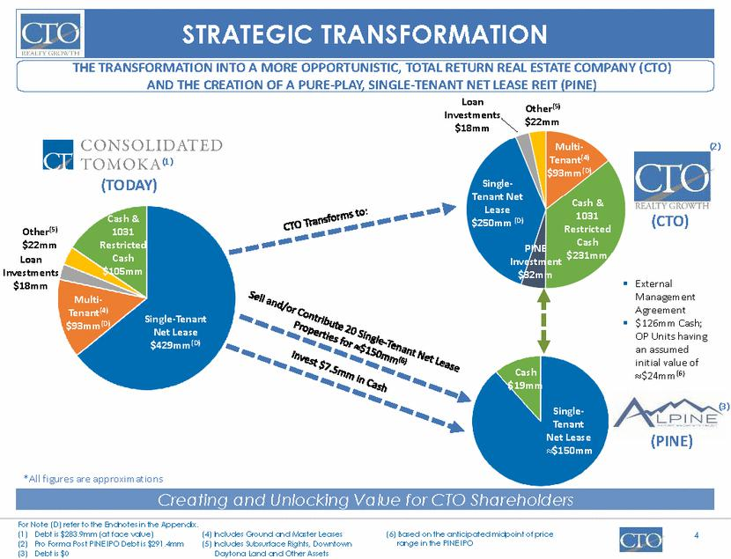

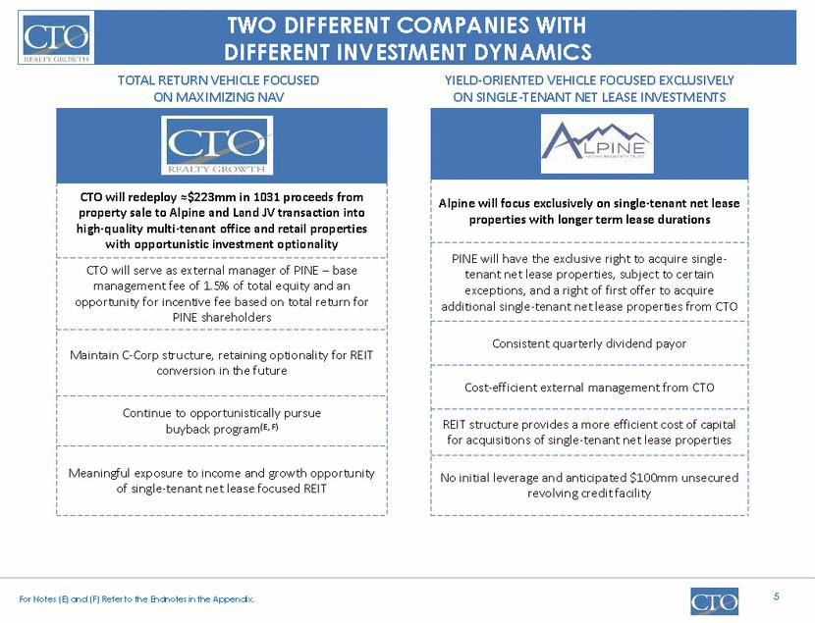

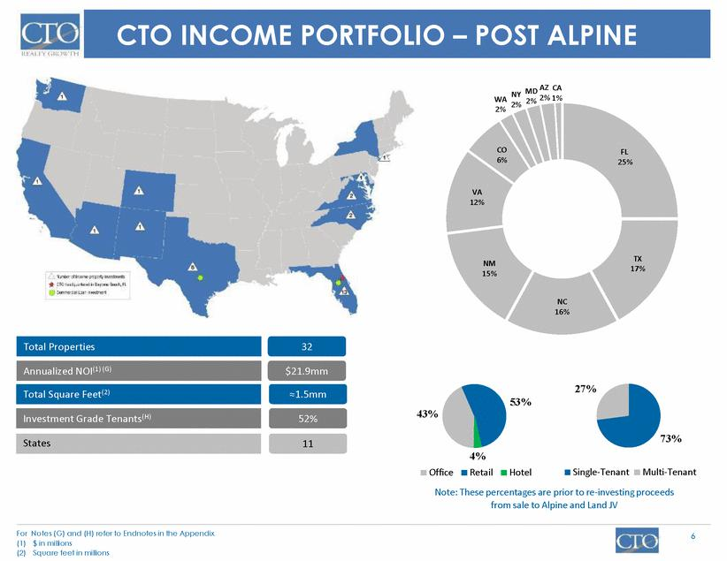

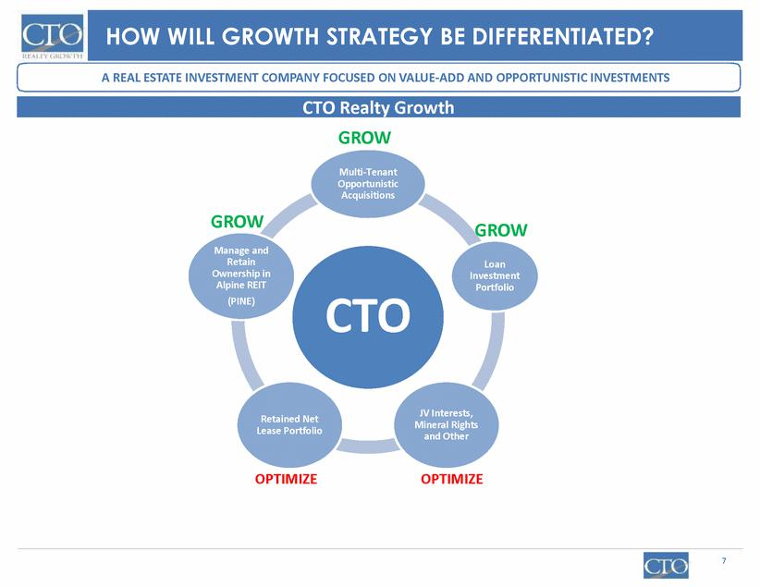

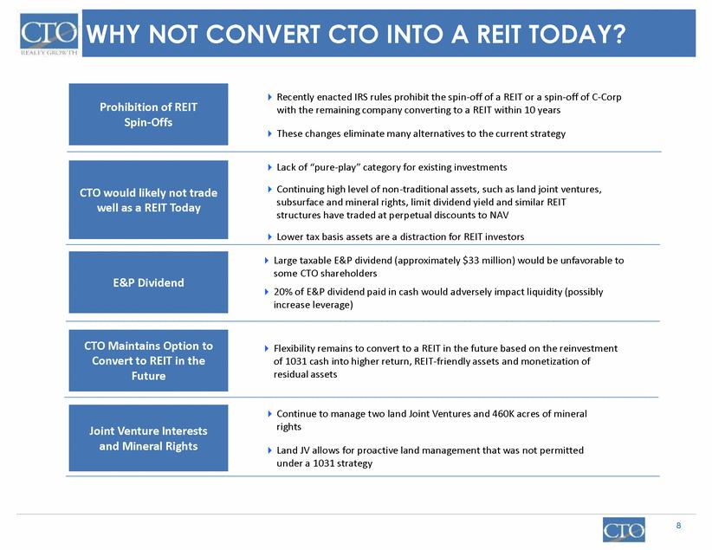

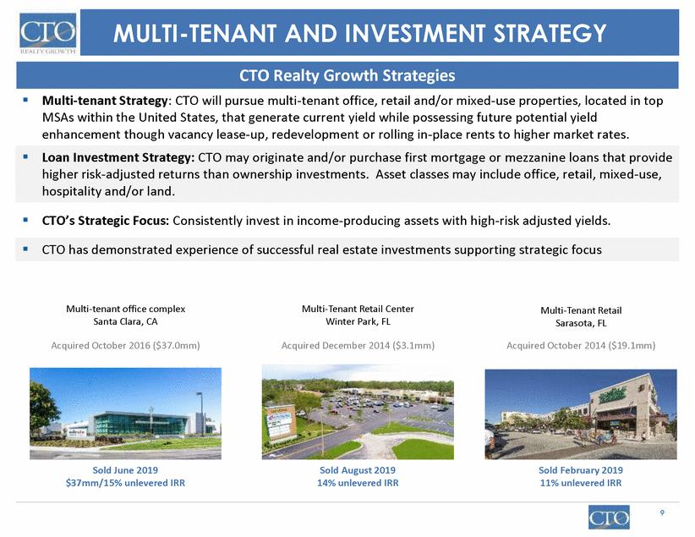

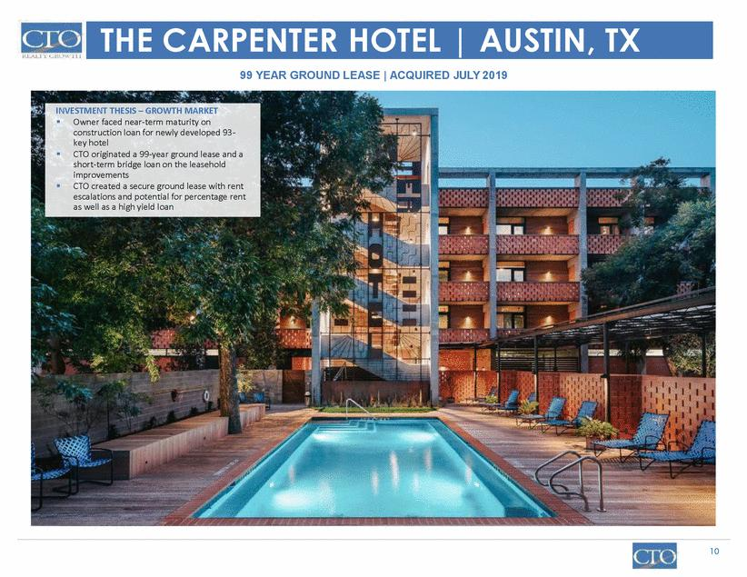

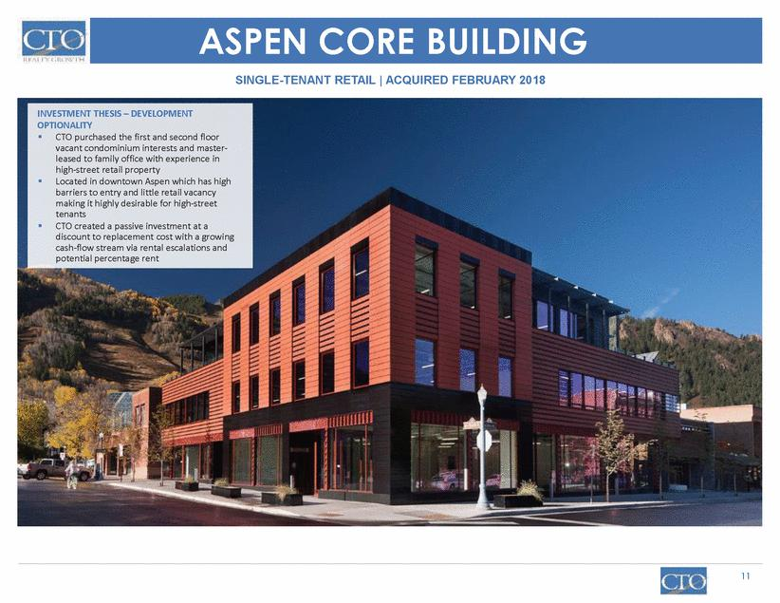

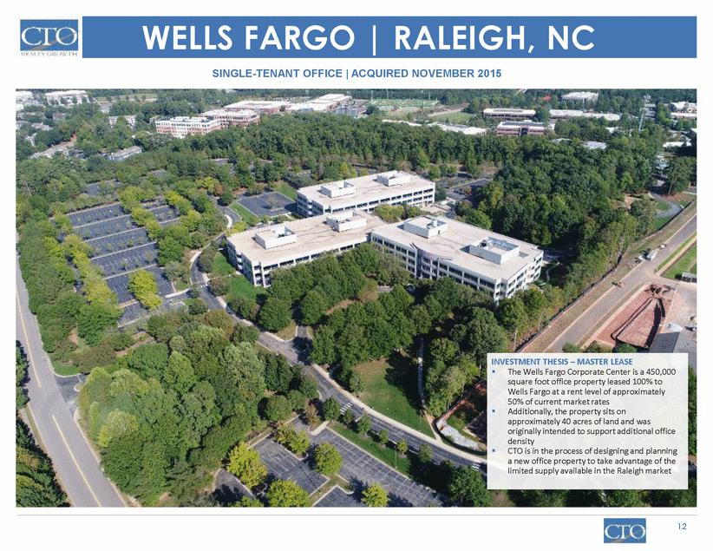

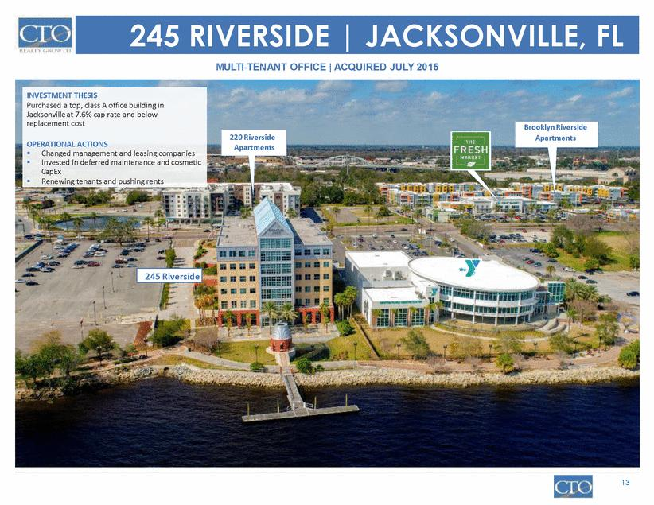

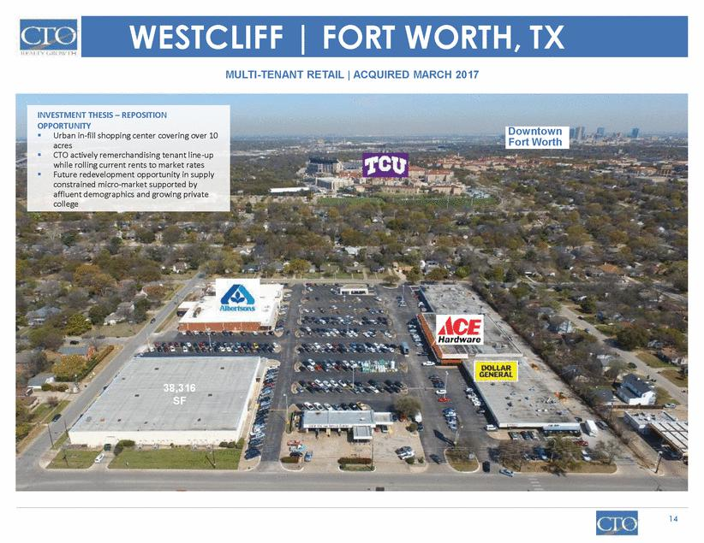

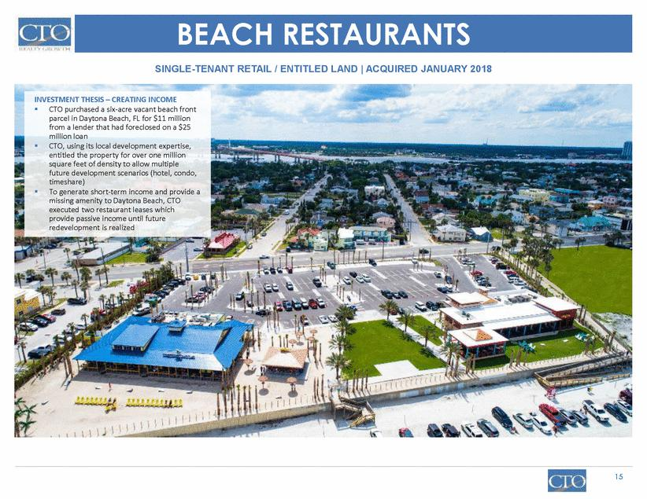

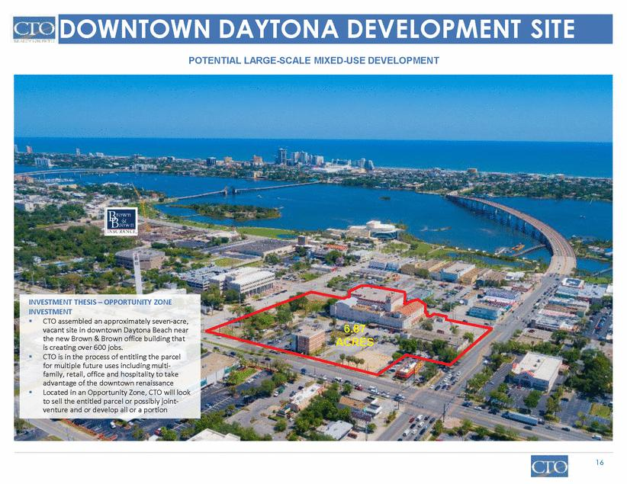

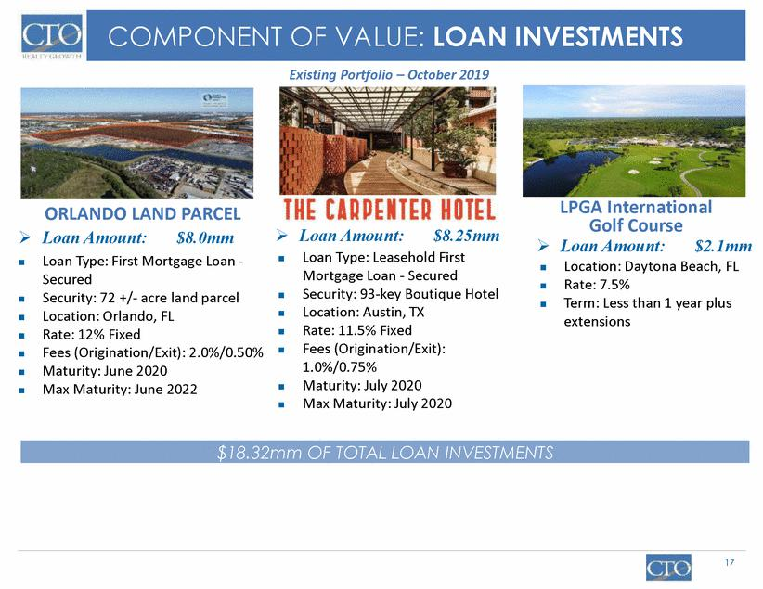

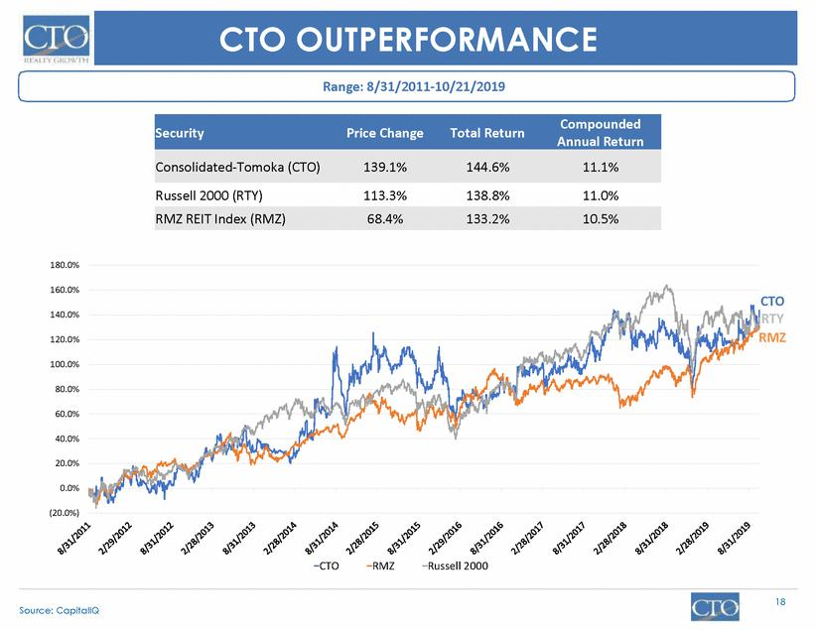

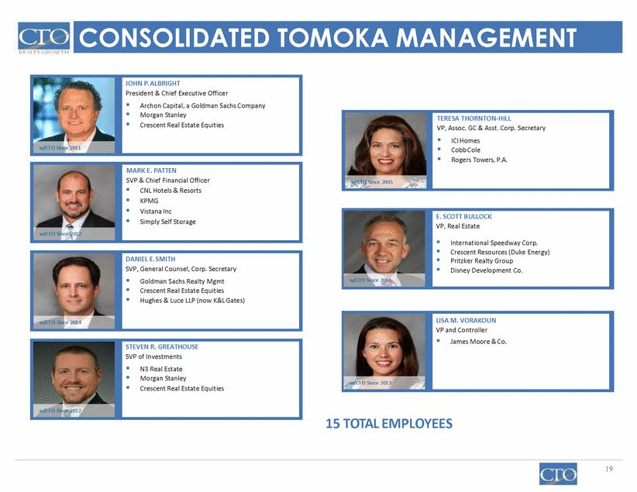

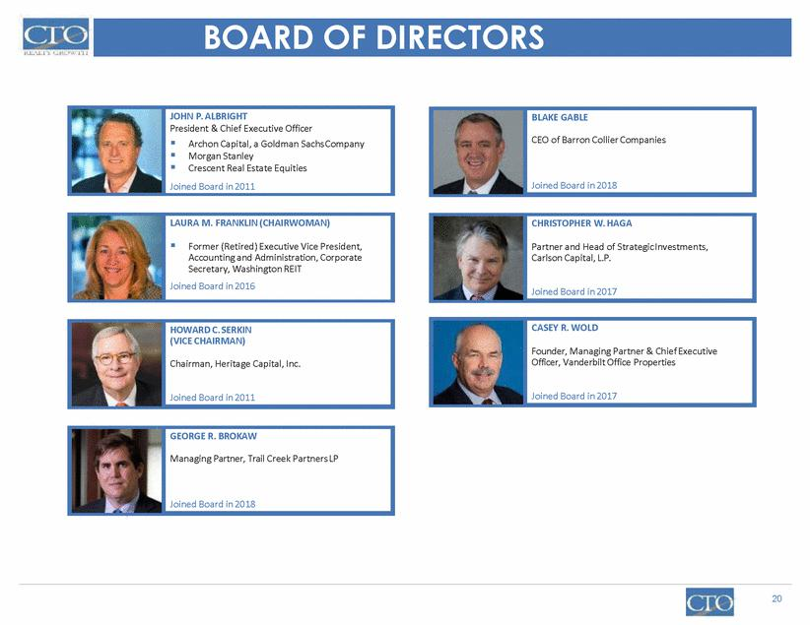

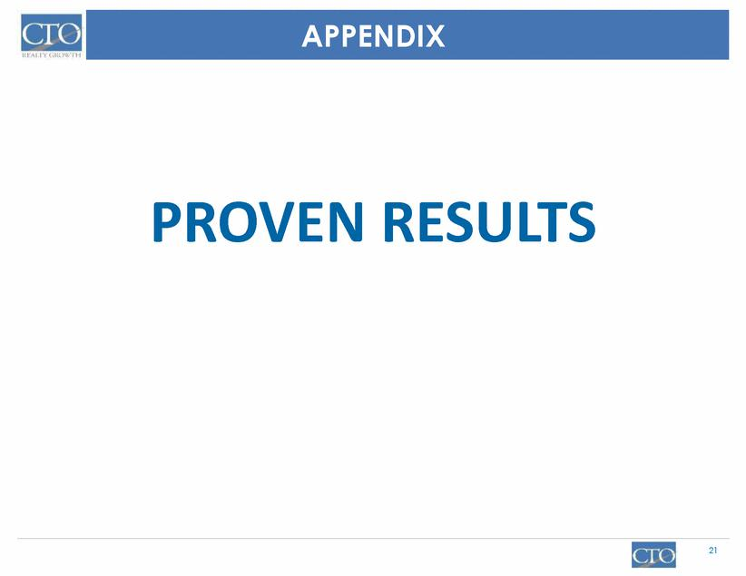

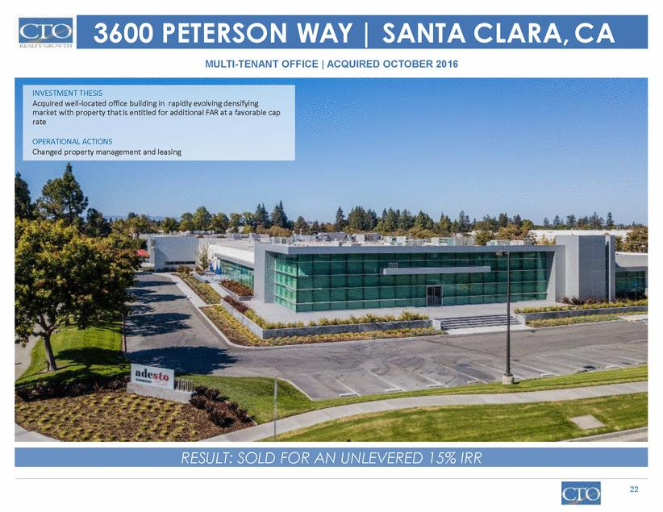

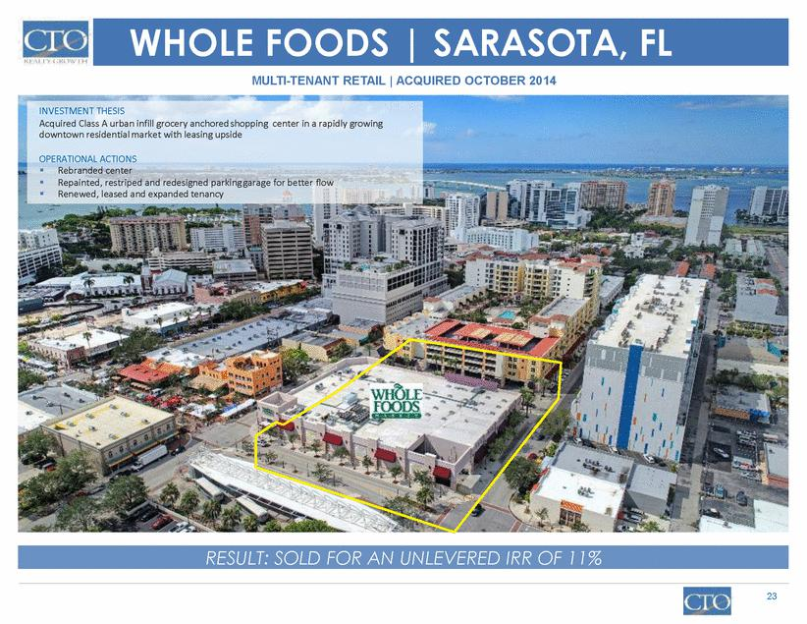

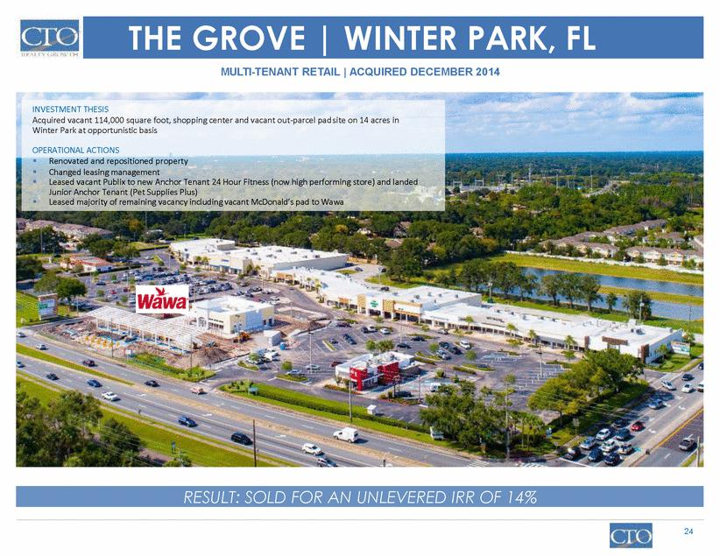

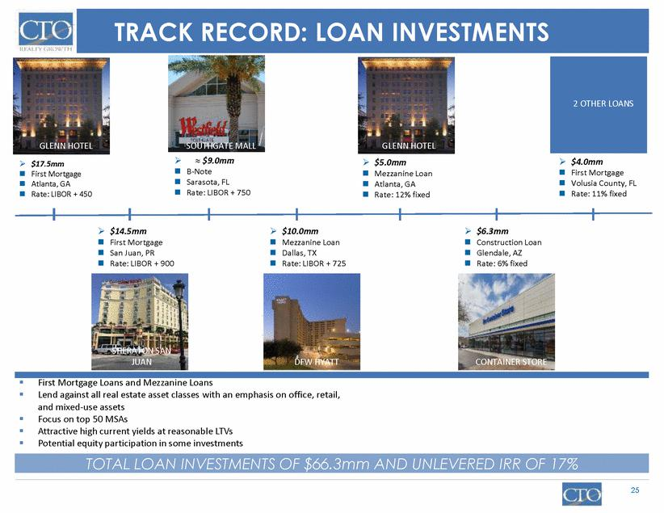

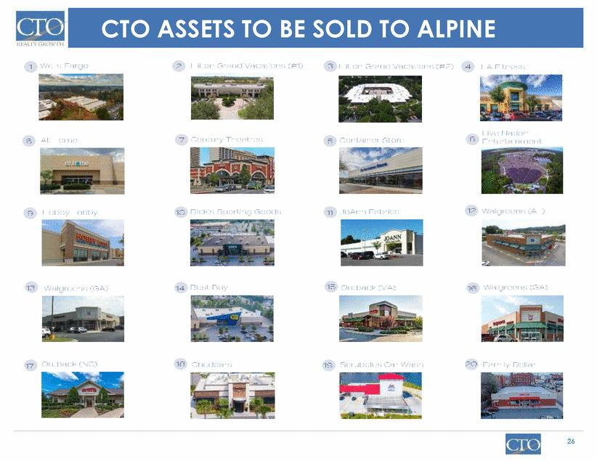

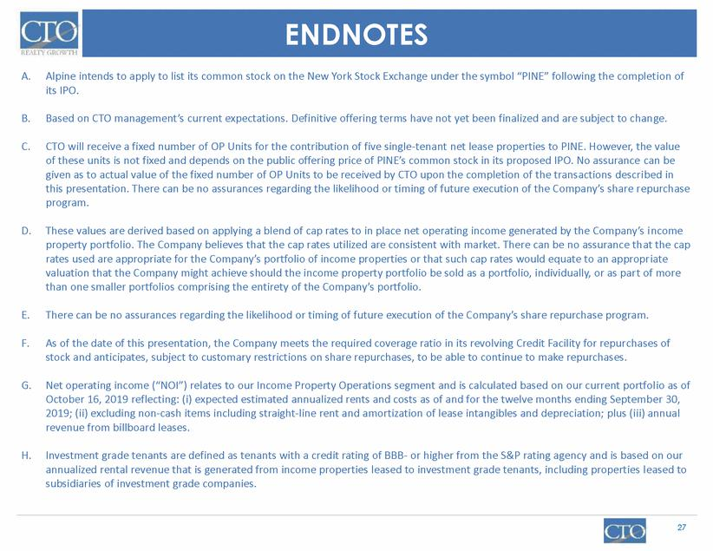

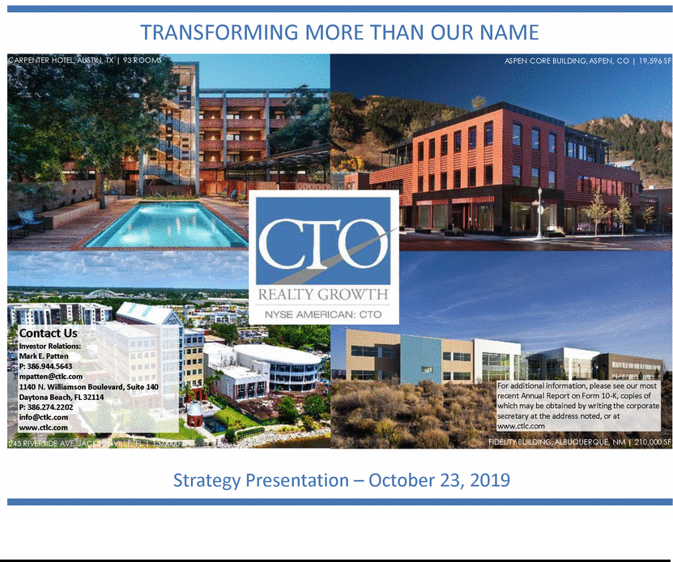

Exhibit 99.2
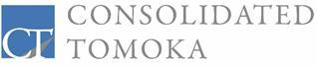

Press

Release

Contact:

Mark E. Patten, Sr. Vice President & Chief Financial Officer mpatten@ctlc.com

Phone:

Facsimile:

(386) 944-5643

(386) 274-1223

FOR | CONSOLIDATED-TOMOKA ANNOUNCES FORMATION AND PLANNED IPO OF
IMMEDIATE | CONSOLIDATED-TOMOKA ANNOUNCES FORMATION AND PLANNED IPO OF
RELEASE | NEW SINGLE-TENANT NET LEASE REIT
 | AND INVESTMENT STRATEGY FOCUSED ON HIGHER RETURN ASSETS
 | CTO to sell and contribute 20 single-tenant properties to newly-formed
 | Alpine Income Property Trust, Inc.
 | Alpine to be externally managed by CTO
 | CTO to focus its investment strategy on higher return multi-tenant office and
 | retail properties
 | CTO to rebrand as CTO Realty Growth, Inc.

DAYTONA BEACH, Fla. – October 23, 2019 – Consolidated-Tomoka Land Co. (NYSE American: CTO) (the “Company” or “CTO”) today announced the creation and planned initial public offering of Alpine Income Property Trust, Inc. (“Alpine” or “PINE”), and CTO’s intention to sell or contribute to Alpine a portfolio of 20 of CTO’s single-tenant net lease income properties (the “IPO Portfolio”). CTO also announced that its investment strategy will focus on higher return real estate assets, and that the Company will rebrand itself as CTO Realty Growth, Inc.

Alpine Transaction

CTO announced the formation of Alpine as an independent single-tenant net lease real estate investment trust (“REIT”), sponsored by CTO. PINE plans to conduct an initial public offering (the “PINE IPO”) in which PINE intends to raise the necessary capital to acquire from CTO 15 of the IPO Portfolio assets for approximately $125.9 million in cash. In addition, as part of PINE’s formation, CTO will contribute to Alpine five of the IPO Portfolio assets in exchange for approximately 1.2 million units in PINE’s operating partnership (“OP Units”). These OP Units

are expected to have a value of approximately $24.5 million based on a preliminary estimate of the mid-point of the public offering price range of the PINE IPO. CTO intends to invest $7.5 million in the common stock of PINE through a private placement concurrent with the IPO. Following completion of the PINE IPO and Alpine’s related formation transactions, CTO's ownership of PINE is expected to total approximately 17.5%, based on the Company’s aggregate ownership of OP Units (approximately 13.4%) and the PINE shares purchased in the private placement (approximately 4.1%). It is intended that Alpine will apply to list its common stock on the New York Stock Exchange under the ticker symbol “PINE” following the completion of its IPO.

At the closing of the PINE IPO, Alpine intends to enter into a management agreement with CTO with an initial term of five years whereby the Company will externally manage Alpine for an annual base management fee equal to 1.5% of the total value of the outstanding equity of Alpine, as well as the opportunity to earn an annual incentive management fee based on the total shareholder returns generated for the shareholders of PINE.

In connection with the management agreement, CTO and Alpine also intend to enter into an exclusivity and right of first offer agreement at the closing of the PINE IPO, pursuant to which any proposed acquisition of single tenant net leased properties by CTO must first be offered to Alpine. In addition, all of CTO’s remaining single tenant net leased properties would be subject to a right of first offer in favor of Alpine should CTO seek to monetize those assets at any time while the management agreement is in effect.

Alpine has filed a registration statement with the U.S. Securities and Exchange Commission (the “PINE S-11”) with respect to the proposed PINE IPO. CTO’s sale and contribution of the IPO Portfolio to Alpine would occur simultaneously with, and is conditioned on, the closing of the PINE IPO.

The Board of Directors of CTO has formed a committee of independent directors to review, negotiate and approve the proposed transactions with Alpine. The transactions remain subject to the final approval of the committee, the execution of definitive agreements on terms acceptable to CTO and the committee, the effectiveness of the PINE S-11 and the satisfaction of all conditions to the closing of the transaction, including the closing of the PINE IPO.

Name Change and Focus of Investment Strategy on Higher Return Assets

CTO also announced that it intends to focus its investment strategy on higher return multi-tenant office and retail properties in strong MSAs and select growth markets throughout the U.S., and intends to rebrand itself as CTO Realty Growth, Inc.

The Company anticipates redeploying the approximately $125.9 million in proceeds from the planned cash sale of the 15 assets to PINE, and the approximately $97 million in proceeds from the recently-announced land joint venture, to acquire properties consistent with our strategy utilizing the 1031 like-kind exchange transaction structure. The Company will maintain its status as a C-corporation while retaining the optionality to convert to a REIT in the future.

John Albright, CTO’s President and Chief Executive Officer, stated, “We are pleased to announce the formation of Alpine and the rebranding of CTO as CTO Realty Growth, reflecting the adjustment in our investment strategy to continue to pursue growth in our net asset value per share through investments in higher return multi-tenant retail and office properties in major MSAs and strong growth markets.” Albright added, “We believe this strategy will create significant value opportunities for CTO, and the growth opportunities presented by our relationship with and ownership in Alpine will also provide the opportunity for maximization of returns for CTO’s shareholders.”

The Company will post a supplemental investor presentation to its website with additional information regarding the Company’s new investment focus. We encourage you to review the supplemental presentation, as well as our most recent investor presentation for the quarter and nine months ended September 30, 2019, available on our website at www.ctlc.com.

This press release does not constitute an offer of securities for sale.

About Consolidated-Tomoka Land Co.

Consolidated-Tomoka Land Co. is a Florida-based publicly traded real estate company, which owns approximately 2.3 million square feet of income properties in diversified markets in the United States and approximately $18 million in real estate loan investments. Visit our website at www.ctlc.com.

We encourage you to review our most recent investor presentations which are available on our website at www.ctlc.com.

SAFE HARBOR

Certain statements contained in this press release (other than statements of historical fact) are forward-looking statements. Words such as “believe,” “estimate,” “expect,” “intend,” “anticipate,” “will,” “could,” “may,” “should,” “plan,” “potential,” “predict,” “forecast,” “project,” and similar expressions and variations thereof are intended to identify certain of such forward-looking statements, which speak only as of the dates on which they were made, although not all forward-looking statements contain such words. Although forward-looking statements are made based upon management’s expectations and beliefs concerning future developments and their potential effect upon the Company, a number of factors could cause the Company’s actual results to differ materially from those set forth in the forward-looking statements. Such factors may include the completion of the PINE IPO, the satisfaction of the closing conditions to the sale and contribution of the IPO Portfolio, completion of 1031 exchange transactions, the availability of investment properties that meet the Company’s investment goals and criteria, the modification of terms of certain land sales agreements, uncertainties associated with obtaining required governmental permits and satisfying other closing conditions for planned acquisitions and sales, as well as the uncertainties and risk factors discussed in our Annual Report on Form 10-K for the fiscal year ended December 31, 2018, as filed with the Securities and Exchange Commission. There can be no assurance that future developments will be in accordance with management’s expectations or that the effect of future developments on the Company will be those anticipated by management.

Readers are cautioned not to place undue reliance on these forward-looking statements, which speak only as of the date of this release.

